**RESPONSE TIME OPTIMIZATIONAND CRITICAL RESPONSE ANALYSIS**

***Assignment by***

* ***Jyoti Prakash***
* ***Abhishek Kumar***
* ***Pragya Sharan***
* ***Madhu Roy***
* ***Md Aarifuzzaman***
* ***Atul Kumar***

**Meet the Team**

**JYOTI PRAKASH *(Team Leader)***

**Designation:** District Fire Officer (Probationer)  
**Education:** B.Tech (Information Technology) – Cochin University of Science and Technology

**ABHISHEK KUMAR**

**Designation:** District Fire Officer (Probationer)  
**Education:** B.Sc (Nautical Science) – T.S. Chanakya, Mumbai Campus

**PRAGYA SHARAN**

**Designation:** District Fire Officer (Probationer)  
**Education:** B.Sc (Zoology Honours) – Patna Science College, Patna University

**MADHU ROY**

**Designation:** District Fire Officer (Probationer)  
**Education:** M.Sc (Chemistry) – Calcutta University

**Md AARIFUZZAMAN**

**Designation:** District Fire Officer (Probationer)  
**Education:** Dual Degree (B.Tech & M.Tech) in Electronics and Communication Engineering – IIT Kharagpur

**ATUL KUMAR**

**Designation:** District Fire Officer (Probationer)  
**Education:** B.Tech (Mathematics and Computing) – IIT Guwahati

**ACKNOWLEDGEMENT**

We would like to take this opportunity to express our heartfelt gratitude to everyone who contributed to the successful completion of this project, **RESPONSE TIME OPTIMIZATION AND CRITICAL RESPONSE ANALYSIS**. This accomplishment is the result of the collective efforts, dedication, and guidance of numerous individuals who supported us throughout the project lifecycle.

First and foremost, we extend our sincere thanks to **Smt. SHOBHA OHATKAR** ma'am, (DG) for providing us with this unique opportunity to undertake this project. Her trust in our abilities and resources helped us grow both personally and professionally.

We are deeply grateful to **Shri M SUNIL KUMAR NAIK** s**ir (IG)**, our mentor, for his invaluable guidance, encouragement, and constructive feedback at every stage of the project. His expertise and insights served as a foundation for our understanding and problem-solving. His mentorship and confidence motivated us to think critically and explore innovative solutions. His patience and consistent support were instrumental in overcoming challenges and steering the project toward its successful conclusion. The valuable infrastructure and supportive environment provided by him made it possible for us to focus our efforts on achieving our goals effectively.

We are thankful to **Shri RAJEEV RANJAN Sir (ASFO -2), Shri RAKESH KUMAR sir (former ASFO-3), Shri MANOJ NAT sir (Sr.Dist Commandant) , Shri Dr. ASHOK KUMAR PRASAD sir (principal CTI, Bihta)**, for their continuous support to our team in this project and facilitation of resources by them.

We also acknowledge the contribution of our colleagues, peers, and team members who worked tirelessly and collaboratively to achieve the project objectives. Each member’s dedication, creativity, and commitment to the shared vision played a crucial role in the project’s success. The spirit of teamwork and mutual respect fostered a positive and productive working environment.

Our gratitude extends to all the stakeholders **(ERSS, ICCC-PATNA, TRAFFIC officials)** and contributors who provided us with necessary resources, data, and insights. Their timely assistance and valuable inputs added depth and precision to our work.

We also recognize the encouragement and support of our families and friends, who stood by us during the demanding phases of the project. Their understanding and motivation gave us the strength to stay focused and persevere.

Lastly, we are thankful for the experiences and learning opportunities this project has provided. The challenges we faced and the skills we acquired have significantly contributed to our growth and will undoubtedly benefit us in future endeavours.

**TABLE OF CONTENT**

**Executive Summary**………………………………………………………………………………..…....5

**Objectives**.…………………………………………………………………….…………………….......….9

**Methodology Used.**………………………………………………………………….....….9

**Introduction**.……………………………………………………………………………....11

**1. Response Time Analysis** ……………………………………………………………....….13

1.1 Current Fire Call Handling Process……………………………………………………..13

1.2 Time Component Breakdown……………………………………………………….....14

**2. Data Collection And analysis**……………………………………………………………..17

2.1 Fire Incident Turnout Times in Bihar………………………………………………………....17

2.2 District Wise Average Travel Time for Fire incidents in Bihar…………………………….......18

2.3 Variation in Response Time During a Day…………………………………………………21

2.4 Impact of Season on Response Time…………………………………………………..….23

**3. Bottleneck Identification** …………………………………………………………………26

3.1 Dispatch Procedures …………………………………………………………………...26

3.2 Alert System……………………………………………………………………….……27

3.3 Personnel Mobilization Analysis………………………………………………….…….28

3.4 Route Selection …………………………………………………………………….…..28

**4. Root Cause Analysis** …………………………………………………………………..…..29

**5. Geographic and Resource Analysis**…………………………………………………..………….31

5.1 Coverage Analysis ……………………………………………………………………..…31

5.2 High-Risk Areas Analysis…………………………………………………………..…………..31

5.3 Population Density Analysis ……………………………………………………………...32

5.4 Traffic Pattern Analysis …………………………………………………………………33

5.5 Road Network Analysis ……………………………………………………………………….33

5.6 Construction Zones Analysis ………………………………………………………………….34

5.7 Natural Barrier Analysis ……………………………………………………………….…35

5.8 Future Development Areas Analysis …………………………………………………………35

**6. Resource Distribution** ………………………………………………………………………….**.**36

6.1 Fire Station location ………………………………………………………………………….36

6.2 Vehicle Positioning …………………………………………………………………………...37

6.3 Personnel Deployment ……………………………………………………………………….38

6.4 Equipment Allocation …………………………………………………………………….…..39

6.5 Mutual Aid and Arrangements ……………………………………………………….…..40

**7.** **SWOT Analysis: Bihar Fire Service Response Time Optimization**………………………..……..42

**8.** **PESTEL Analysis: Bihar Fire Service Response Time Optimization**……………………..……….42

**9. Optimization Strategy** ………………………………………………………………..…….44

9.1 Call Handling Optimization ………………………………………………………….…44

9.2 Dispatch Time Optimization ………………………………………………………..….45

9.3 Route Optimization ………………………………………………………………....…45

9.4 Resource Deployment ………………………………………………………………....46

9.5 Training Enhancement ………………………………………………………………...46

9.6 Technology Integration ………………………………………………………………..47

**10. Implementation Framework** ………………………………………………………………….48

10.1 Short-term Improvements (0-3 months) …………………………………………………...48

10.2 Medium-term Solutions (3-12 months) ……………………………………………………48

10.3 Long-term Strategies (1-3 years) …………………………………………………………...49

10.4 Resource Requirements ……………………………………………………………………49

10.5 Training Needs …………………………………………………………………………..…50

10.6 Budget Implications ………………………………………….………………………….…50

**CONCLUSION** …………………………………………………………………………………..….51

**Executive Summary**

This report presents a comprehensive evaluation of the **Bihar Fire Service’s emergency response framework**, identifying inefficiencies, analysing key performance indicators, and proposing actionable recommendations. Drawing from data on over **7,000 fire incidents reported between November 2023 and October 2024**, the study investigates critical areas such as response time, resource allocation, and geographical coverage. The report provides a phased implementation strategy aimed at achieving a **more effective and efficient emergency response system.**

**Current Performance Assessment of Bihar Fire Service**

The average response time for the state of Bihar is **18 minutes 54 seconds**. The upgradation and modernisation of Bihar Fire Service will improve its response time further. However, currently the performance of the Bihar Fire Service is hampered by delayed response time. insufficient resource allocation, and outdated processes. Urban districts such as Patna and Samastipur report the highest number of fire incidents, while rural districts like Jamui and West Champaran suffer the longest delays due to inadequate connectivity and resources. Seasonal analysis indicates that fire incidents peak during summer months, with response times severely affected by traffic congestion in urban areas and inaccessibility in rural regions. The average turnout time for the state of Bihar comes out to be **2.16 minutes.** Efficient districts like Madhubani record response times under two minutes, while critical districts like Gopalganj exceed three minutes. However, during our field visits we found the turnout time to be **under 2 minutes**.

**Data Collection and Analysis**

The report is based on extensive data collection across **40 revenue districts in Bihar** during a 12-month period. The analysis leverages **GIS mapping** and data visualization tools such as Tableau to identify trends, high-risk zones, and travel time discrepancies. High-frequency incident areas like **Patna** and **East Champaran** contrast sharply with rural districts like **Banka** and **Sheohar**, where incidents are fewer but response times are significantly longer. Hourly trends reveal peak delays during **mid-afternoon and evening hours**, correlating with traffic congestion and operational fatigue.

**Time Component Breakdown**

The response process of the Bihar Fire Service comprises multiple stages, from **incident reporting** to **resource deployment**. Delays occur at various points:

* **Reporting Delays:** Manual entry processes and insufficient training for operators prolong the initial reporting phase.
* **Dispatch Delays**: Manual coordination between state, district, and station control rooms adds **80–100 seconds** to response time.
* **Turnout Delays**: Inefficient vehicle preparation and reliance on manual alert mechanisms increase readiness time by an additional 40–50 seconds.

The total time from receiving a call to dispatching resources ranges from **110–145 seconds,** with further delays added for incidents reported via **ERSS (Emergency Response Support System).**

**Bottleneck Identification**

The study identifies systemic bottlenecks in the Bihar Fire Service’s operations:

* **Manual Processes:** Dispatch and communication rely heavily on manual inputs, leading to avoidable delays.
* **Inadequate Coordination:** Poor inter-agency collaboration between fire services, traffic management, and emergency response centres.
* **Limited Training:** Operators and personnel lack the skills to efficiently utilize modern systems and tools.
* **Outdated Alert Systems**: Manual bells and other traditional systems fail to provide timely notifications.

These bottlenecks are particularly detrimental during peak fire seasons when high call volumes overwhelm existing resources.

**Root Cause Analysis**

The inefficiencies identified stem from both operational and infrastructural challenges:

* **Infrastructure Gaps**: Inadequate fire station coverage and poorly maintained roads in rural districts hinder rapid response.
* **Resource Shortages**: Outdated vehicles, insufficient firefighting tools, and undertrained personnel reduce operational readiness.
* **Technological Deficiencies**: Lack of real-time GIS mapping and dynamic routing systems further exacerbate delays.
* **Environmental Barriers**: Seasonal floods, fog, and forested areas in districts like **Jamui** and **Bhagalpur** restrict accessibility and delay responses.

**Coverage Analysis**

Bihar operates **107 fire stations**, falling significantly short of national guidelines, particularly in rural areas. Urban districts like **Patna** and **Muzaffarpur** are relatively well-covered, but regions such as **Sheohar** and **Arwal** remain critically underserved. **High-risk** **zones**—including **Patna’s** congested old city areas and industrial hubs like **Hajipur**—require additional resources to manage frequent incidents. Geographic obstacles, including rivers and flood-prone areas in districts like **Darbhanga**, further restrict coverage.

**Resource Distribution**

The Bihar Fire Service operates **798 vehicles**, including **255 water tenders**, many of which are outdated and frequently break down. Personnel shortages, particularly in leadership roles like **District Fire Officers**, exacerbate inefficiencies. The **absence of modern**

**equipment** and inconsistent maintenance protocols further hinder operational readiness. Budget constraints limit the procurement of additional resources, leaving several high-risk districts critically under-equipped.

**Optimization Strategy**

The report outlines a structured strategy for improving the Bihar Fire Service’s operational efficiency:

* **Call Handling Optimization**: Implement **standardized scripts** and **predefined priority codes** to streamline information collection and decision-making. Promote **app-based reporting** integrated with GPS to expedite incident tracking and response.
* **Turnout Time Optimization:** Introduce **smart dispatch systems** capable of multi-channel notifications and **pre-alert mechanisms** to reduce readiness delays. Digitize workflows to eliminate manual data entry processes.
* **Route Optimization:** Collaborate with traffic authorities to integrate **real-time traffic data** into navigation systems. Employ **drone-assisted navigation** for surveillance and route planning, and establish **dedicated emergency lanes** in high-traffic areas.
* **Resource Deployment**: Increase fire station coverage in underserved areas and develop a network of **volunteer brigades** for rural districts. Prioritize the acquisition of modern firefighting vehicles and equipment.

**Technology Integration**

Technological advancements are essential for modernizing the Bihar Fire Service. The report recommends:

* **AI-Based Predictive Analytics**: Utilize AI tools to analyze historical and real-time data for proactive resource planning.
* **Drone Deployment:** Equip drones with thermal imaging to assess fire scenes and enhance situational awareness.
* **VR/AR Training Programs:** Leverage virtual and augmented reality to simulate diverse fire scenarios and improve decision-making skills.
* **Integrated Communication Systems**: Adopt unified platforms for real-time coordination between fire services, traffic management, and other emergency response agencies.

**Implementation Framework**

The recommendations are structured into three implementation phases:

* **Short-Term (0–3 Months):**
  + Digitize incident reporting processes and integrate **GIS tools.**
  + Begin app-based fire incident reporting and train personnel in modern navigation systems.
* **Medium-Term (3–12 Months):**
  + Open additional fire stations in high-risk zones and enhance communication infrastructure.
  + Implement multi-channel dispatch systems and reform personnel shifts to reduce fatigue.
* **Long-Term (1–3 Years**):
  + Procure modern vehicles and deploy **IoT-enabled sensors** in high-risk zones.
  + Build **dedicated emergency lanes** and integrate **AI-based tools** for fire risk prediction and resource allocation.
  + Expand VR/AR-based training programs and improve inter-agency collaboration.

**Conclusion**

The Bihar Fire Service’s operational framework is hindered by outdated infrastructure, resource shortages, and limited adoption of modern technologies. This report provides a comprehensive roadmap to overcome these challenges, focusing on improving response times, optimizing resource utilization, and strengthening inter-agency coordination. By implementing the recommended strategies, the Bihar Fire Service can transform into a **highly efficient and responsive emergency system**, ultimately safeguarding lives and property across the state.

**I. Objectives**

The primary objectives of this report are as follows:

1. **Analyze Emergency Response Time**: Assess the current performance of emergency response time and identify gaps in Bihar Fire Service.
2. **Identify Bottlenecks**: Diagnose critical delays in the response process and their underlying causes.
3. **Evaluate Influencing Factors**: Examine geographic, infrastructural, and resource-related factors that impact response time.
4. **Recommend Optimizations**: Provide actionable recommendations for reducing response time and improving overall efficiency.
5. **Implementation Strategies**: Develop a roadmap for short-term, medium-term, and long-term implementation of improvements.

**II. Methodology used**

The methodology integrates quantitative and qualitative approaches, including data analysis, field research, and stakeholder consultation. The key steps are as follows:

**1. Data Collection**

* **Historical Data Analysis**: Examination of fire response data from November 2023 to October 2024.
* **Scenario Mapping**: Tracking response time across diverse fire incidence scenarios to identify trends and deviations.

**2. Performance Metrics**

* **Time Component Analysis**: Assessment of delays at each stage, including:
  + Reporting time.
  + Call processing time.
  + Turnout time.
  + Travel time
  + Setup time.

**3. Stakeholder Engagement**

* **Interviews**: Conducted with key personnel, including:
  + Dispatchers at ERSS and State Fire Control Room.
  + Field responders (ADFO, Station Officers, Leading Firemen, Firemen Driver and Firemen)
  + Resource managers (District Fire Officers and Additional State Fire Officer, Ex State Fire Officer.)
* **Field Visits**: Engagements at offices, such as:
  + Kankarbagh Fire Office.
  + Munger District Fire Office.
  + Patna District Fire Office.
  + Lodipur and Patna City fire office.
* **Meetings and discussions with:** 
  + Traffic officials (Traffic SP and DSP) and Police Information Room (PIR).
  + SP and Additional SP at Emergency Response Support System (ERSS) representatives.
  + Consultants of ERSS project from Ernst Young (EY).
  + Integrated Command and Control Centre (ICCC) Patna Smart City.
  + Fire officials (DFO Patna and Munger, Principal BFTA, ASFO-3, SFO).

**4. Tools and Techniques**

* **Geographic Analysis**: Utilized software such as Tableau and ChatGPT to identify spatial response challenges.
* **Root Cause Analysis**: Applied structured frameworks to determine key bottlenecks and their resolution pathways.

**Introduction**

Fire incidents pose a critical challenge for emergency response systems, especially in regions with diverse geographic and resource constraints. This report analyzes fire incidents across Bihar from **November 2023 to October** 2024 (7000+ fire incidents), providing a detailed district-wise breakdown of incidents. The objective is to identify high-risk regions, highlight areas of concern, and propose actionable strategies for optimizing response time and mitigating fire-related risks.

The study reveals significant regional disparities in fire incident occurrences. Notably

* **East Champaran** and **Patna** districts recorded the highest fire incidents 415 and 453 respectively highlighting a concentration of fire emergencies in central Bihar.
* Conversely, districts such as **Banka (53)**, **Rohtas (77)**, and **Buxar (87)** reported comparatively fewer incidents.
* Fire hotspots were prominently identified in **Central Bihar**, while southern and northern districts exhibited moderate to low fire incidents.

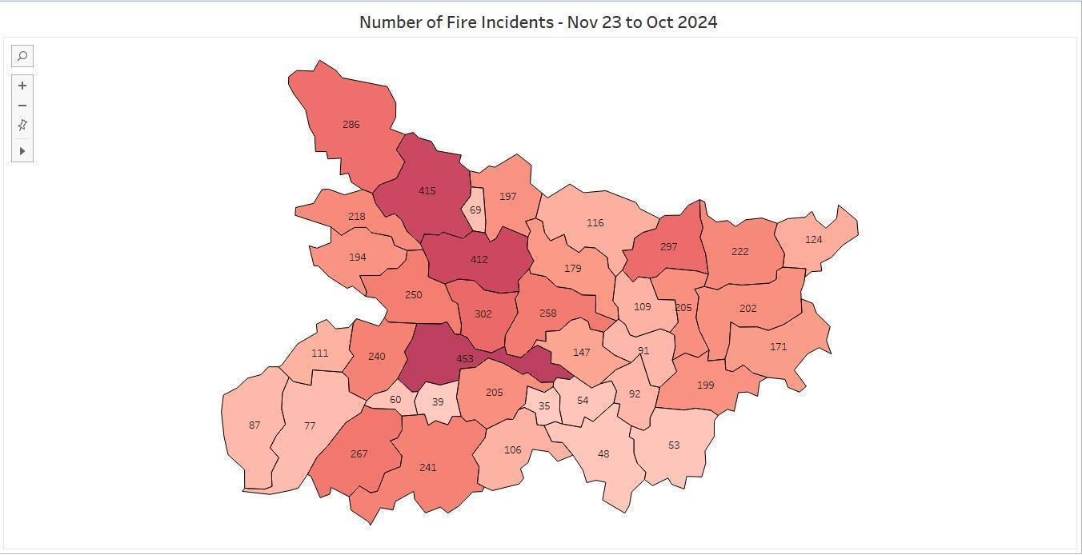

**Image:** Heat map of Bihar which shows number of fire incidents reported (Nov 2023 to Oct 2024)

To visually represent these disparities, a district-wise heat map was created, where darker shades signify higher fire incidents and lighter shades denote lower frequencies. This visual analysis offers an intuitive understanding of the distribution of fire incidents across Bihar.

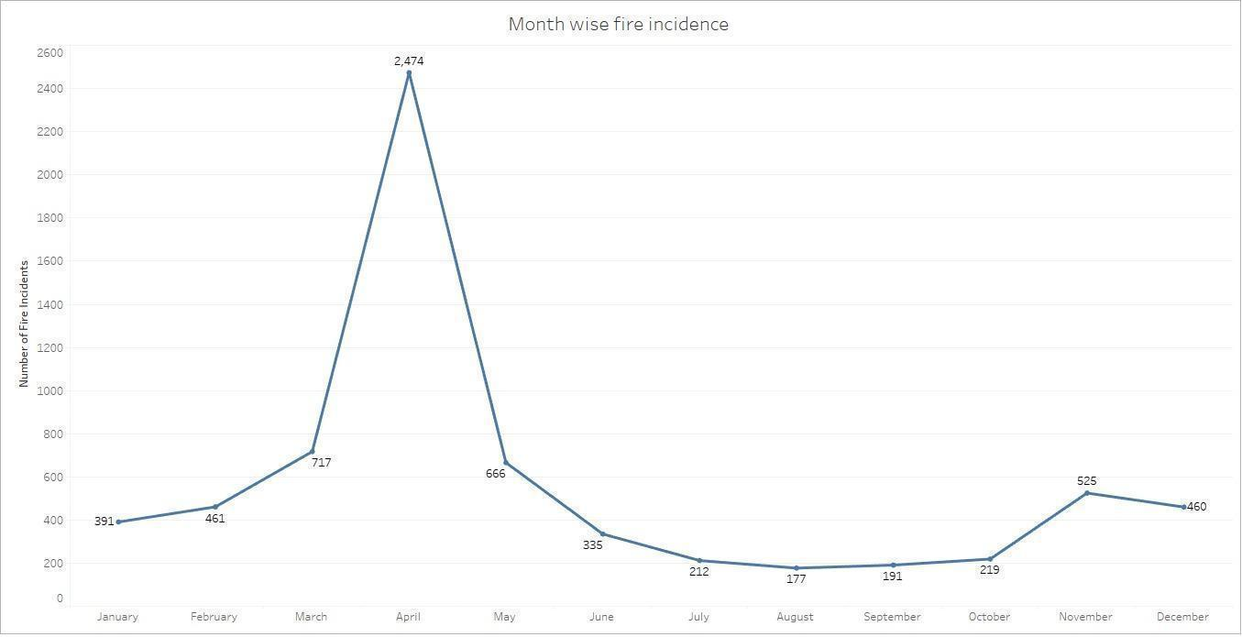

**Image:** Month wise spread of fire incidents

The fire incident data in Bihar reveals distinct seasonal and monthly patterns. The analysis shows a significant peak in fire incidents during the summer months and a sharp decline during the monsoon season.

**PART 1: RESPONSE TIME ANALYSIS**

**Current Performance assessment of Bihar Fire Service**

**1.1 Current fire call handling process**

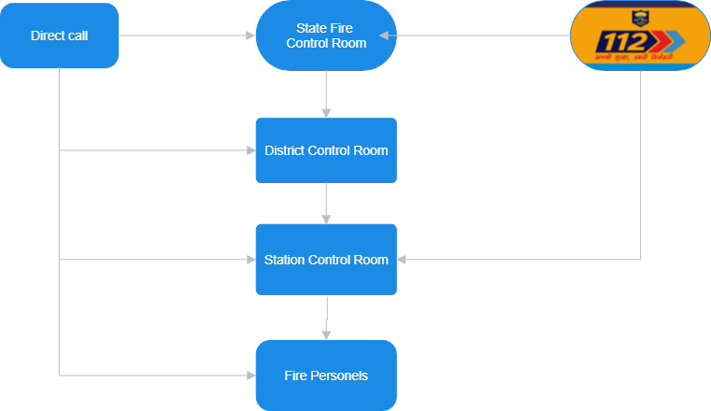

**Image:** Flowchart of fire call handling process.

The flowchart demonstrates a multi-level approach to fire call handling, starting from call reception at the State Fire Control Room (via direct calls or Dial 112) and moving through the District and Station Control Rooms to ensure rapid deployment of fire personnel.

1. **Call Origination**:
   * **Direct Call**: A citizen in need of fire service can directly call the **State Fire Control Room** to report an emergency.
   * **Dial 112**: Calls made to the **112 Emergency Number** (a national helpline for emergencies) are routed to the **State Fire Control Room**.
2. **State Fire Control Room**:
   * This is the central hub for receiving fire-related calls. It assesses the situation and determines the appropriate response.
   * After verifying the emergency, the information is passed to the relevant **District Control Room or Station Control Room**.
3. **District Control Room**:
   * The District Control Room acts as an intermediary, coordinating between the State Fire Control Room, Station control room, Traffic police and other departments as and when required.
   * It forwards the details of the fire emergency to the relevant **Station Control Room**.
4. **Station Control Room**:
   * Upon receiving instructions from the District Control Room or from Dial 112, it dispatches fire personnel and resources to the emergency location.
   * In some cases, direct calls are received to the fire personnel in the fire station.
5. **Fire Personnel Deployment**:
   * Firefighters and equipment are mobilized from the nearest fire station to address the emergency.
   * Communication between the State Fire Control Room, District Control Room, and Station Control Room ensures a streamlined and efficient response.

**1.2 Time Component breakdown**.

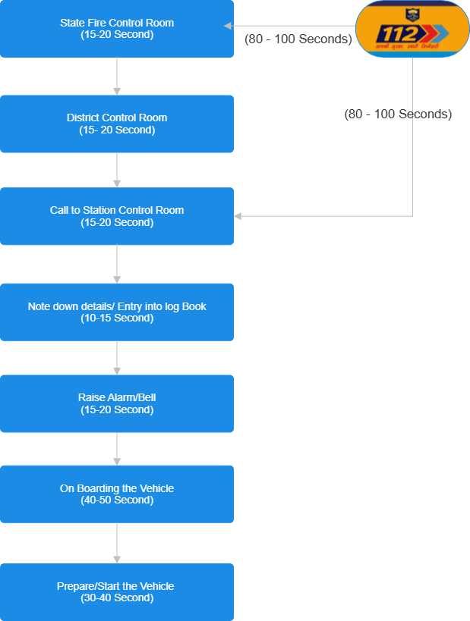

**Image:** Time component breakdown

The flowchart provides a time breakdown for each stage in the process of handling a fire call in the Bihar Fire Service. Here’s a step-by-step description of the stages and the time taken at each step:

1. **Emergency and Response system (ERSS) (80-100 seconds)**
   * When an emergency call is received, call takers at the ERSS:

- Record the details of the call.

- Create an event entry.

* + The caller's location is identified using location-based services (LBS).
  + The information is sent to fire personnel at the ERSS through a computer-aided dispatch (CAD) application.
  + The fire personnel forward the call to state fire control room or Station Control Room

1. **State Fire Control Room (15–20 seconds)**:
   * The process begins when the State Fire Control Room receives the emergency call.
   * The staff collects the relevant information to assess the situation and forwards the details to the relevant District Control Room.
   * Here the details are manually entered into the log book and manually details are recorded on paper.
2. **District Control Room (15–20 seconds)**:
   * The District Control Room receives the information from the State Fire Control Room.
   * It processes the call and contacts the appropriate Station Control Room.
   * Similar to the State fire control room here also details are recorded manually.
3. **Call to Station Control Room (15–20 seconds)**:
   * The Station Control Room is informed of the emergency by the District Control Room.
   * The details of the situation are relayed, initiating further action.
4. **Note Down Details/Entry into Log Book (10–15 seconds)**:
   * The Station Control Room staff notes down the critical details of the fire emergency and records them in the logbook for documentation.
   * Here also the details are manually processed and note/details are passed on to the firemen driver.
5. **Raise Alarm/Bell (15–20 seconds)**:
   * An alarm or bell is raised to alert the fire personnel and mobilize them for action.
   * Most of the fire stations have manual bells which adds an additional 10-12 seconds to the overall time.
6. **Onboarding the Vehicle (40–50 seconds)**:
   * Firefighters board the emergency vehicle, ensuring that all necessary personnel are ready to respond.
   * This step is critical for assembling the team and preparing for dispatch.
7. **Prepare/Start the Vehicle (30–40 seconds)**:
   * The vehicle is started, and final checks are performed to ensure that it is ready for deployment.
   * Here depending on the vehicle (old/new) time may increase as old vehicles need more time to maintain the pressure in the braking system before they are dispatched. This time is less for the districts like Patna, Gaya, Muzaffarpur and others where mostly new water tenders are deployed.
   * Once this step is completed, the firefighting team proceeds to the emergency location.

**Total Time:**

The turnout time takes approximately **110–145 seconds** (1 minutes and 50 seconds to 2 minutes and 25 seconds) from receiving the fire call to the Station control room to being fully prepared for deployment. However, if the call is received through ERSS the turnout time increases by approximately 80 to 100 seconds.

**2. Data Collection and analysis**

This report is based on the analysis of the fire incidents reported across Bihar from November 2023 to October 2024 (7000+ fire incidents).

# 2.1 Fire Incident Turnout Times in Bihar

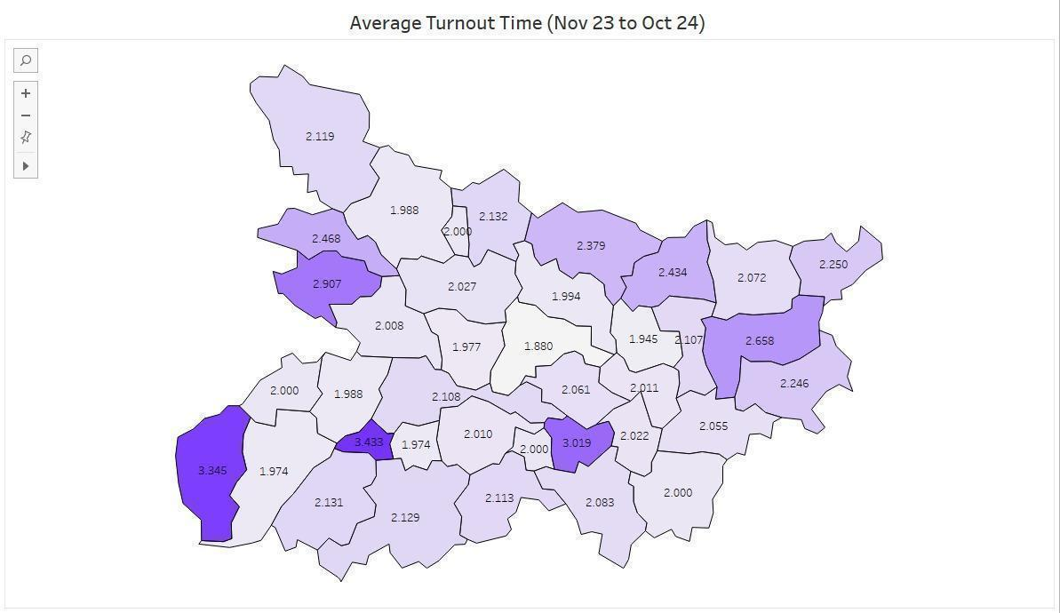

Image 3: Average turnout time 2 Minutes 10 Seconds

## 2.1.1. Districts with High Turnout Times (Above 3.0 Minutes)

* Arwal (3.433 minutes)
* Bhabua (3.345 minutes)
* Lakhisarai (3.019 minutes)

## 2.1.2 Districts with Moderate Turnout Times (2.0 to 3.0 Minutes)

* Begusarai (2.061 minutes)
* Araria(2.072 minutes)
* Katihar (2.246 minutes):
* Supaul (2.434 minutes)
* Gopalganj (2.468 minutes)
* Purnia (2.658 minutes)
* Siwan (2.907 minutes)

## 2.1.3. Districts with Low Turnout Times (Below 2.0 Minutes)

* Darbhanga (1.994 minutes):
* Jehanabad (1.974 minutes):
* Vaishali(1.977 minutes):
* East Champaran (1.988 minutes):

**Insights from the Analysis**

* + 1. Critical Areas: Arwal, Bhabua, and Lakhisarai are the most critical districts with response times exceeding 3 minutes, mainly due to rough terrain and lack of proper infrastructure like road connectivity.
    2. Moderate Regions: Districts like Patna, Purnia, and Siwan show moderate response times due to urban congestion or resource allocation challenges. With targeted measures, their performance can improve significantly.
    3. Efficient Regions: Darbhanga, Vaishali, and Jehanabad are excellent examples of efficient fire service response systems. These districts can serve as benchmarks for other areas.

**2.2 District-Wise Average Travel Time for Fire Incidents in Bihar**

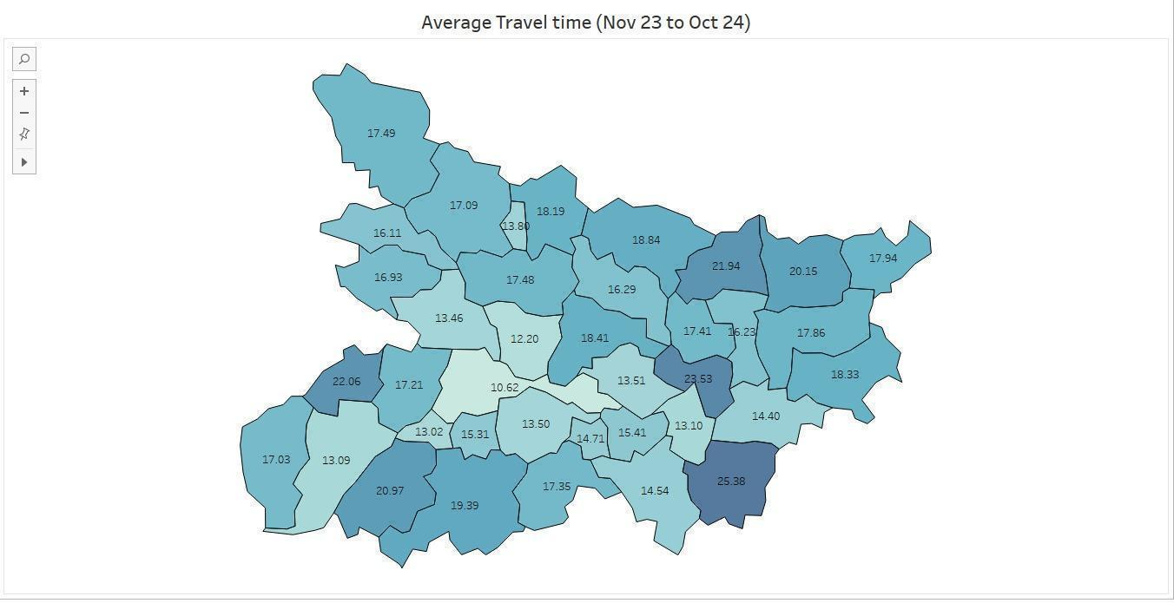

**Image:** District wise average travel time**.**

Below table lists the average travel time (Based on last Year’s fire incidents) and the factors which influence the travel time in that particular district.

| **District** | **Travel Time (minutes)** | **Infrastructural Factors** | **Geographical Factors** | **Demographical Factors** | **Insights** |
| --- | --- | --- | --- | --- | --- |
| Jamui | 14.54 | Poor road connectivity; Sparse fire stations | Hilly and forested terrain | Low population density and rural, scattered settlements | Terrain and poor infrastructure delay response time |
| Gaya | 19.39 | Remote areas lack proper roads; Limited fire stations | Plateau and forested terrain | Large population (~4.4 million); Urban-rural mix | Connectivity issues and resource limitations increase response times. |
| Buxar | 22.06 | Uneven infrastructure; Fire station coverage gaps | Flood-prone plains near the Ganges | High rural density (~1,112/sq km) | Limited infrastructure and road issues delay response times. |
| Aurangabad | 20.97 | Roads require maintenance; Sparse rural coverage | Semi-arid and dry land | Predominantly rural (~2.5 million) | Infrastructure gaps hinder timely response. |
| Nawada | 17.35 | Poor road connectivity; Limited infrastructure | Hilly and forested terrain | Urban-rural mix | Geographical and infrastructure constraints delay responses. |
| Muzaffarpur | 17.48 | Good NH connections; Poor rural road network | Flood-prone plains | Highly populated (~5 million); High density (1,514/km²) | Population pressure and flooding contribute to delays. |
| Purnia | 17.86 | Limited rural infrastructure | Riverine floodplains prone to inundation | Predominantly rural | Flooding and lack of infrastructure affect travel time. |
| Kishanganj | 17.94 | Sparse fire stations | Riverine geography | Low population density (~898/sq km) | Limited infrastructure in flood-prone areas increases delays. |
| Sheikhpura | 14.71 | Better road connectivity; Proximity to urban areas | Flat terrain | Small population (~600,000) | Less travel time due to small population size. |
| Vaishali | 12.20 | Decent road network; Gaps in rural infrastructure | Plains with moderate terrain | Population pressure (~3.5 million) | Decent connectivity ensures low response times. |
| Lakhisarai | 15.41 | Limited road coverage in rural areas | Mixed terrain | Small population (~1 million) | Infrastructure improvements required for further efficiency. |
| Begusarai | 13.51 | Moderate infrastructure; Better urban connectivity | Flat terrain, no major constraints | High population (~3.7 million) | Urban-centric response benefits travel time; rural areas lag behind. |
| Nalanda | 13.50 | Moderate road infrastructure; Gaps in fire station coverage | Mostly flat terrain | High rural-urban mix (~2.9 million) | Infrastructure gaps impact response efficiency. |

**2.3 Variation in response time during the day.**

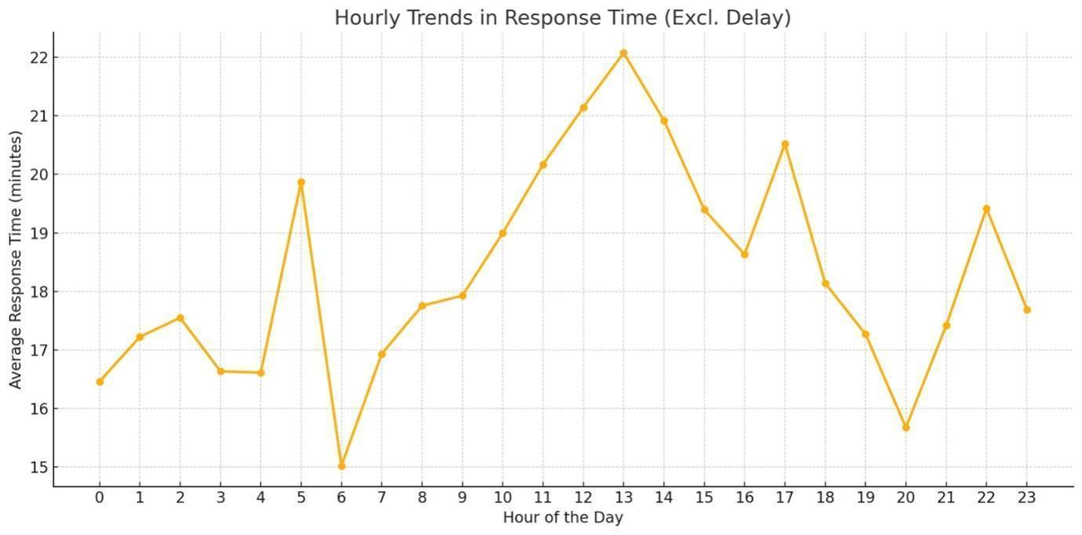

**Image:** Hourly variation in response time during the day.

**Fluctuating Response Times**: The average response time varies significantly throughout the day, suggesting variations in workload or operational efficiency at different times.

1. **Peak Response Time**:
   * The highest average response time is around 13:00 (1 PM), indicating congestion or reduced availability of vehicles during this period.
   * Other notable peaks are at 5:00 (early morning), 17:00 (5 PM), and 22:00 (10 PM).
2. **Lowest Response Times**:
   * The lowest average response time occurs around 6:00 (early morning) and 20:00 (8 PM), which could correspond to reduced user activity or increased efficiency during these hours.
3. **Morning to Afternoon Trend**:
   * Response times generally increase from the early morning (6:00–7:00) and peak by mid-afternoon. This could be indicative of increased workload or traffic during business hours.
4. **Evening Drop**:
   * There is a noticeable decline in response times in the evening (18:00–20:00), suggesting reduced user demand or increased staffing during these hours.
5. **Night time Stability**:
   * During late-night hours (0:00–3:00), the response times remain relatively stable and moderate, likely reflecting low activity levels.

### Reasons for Hourly Delays

1. **Morning Delays (5:00 AM–7:00 AM)**:
   * Fewer personnel on duty during early hours.
   * Fog and poor visibility during winter mornings.
   * Incidents in rural areas may take time to report.
2. **Afternoon Peaks (2:00 PM)**:
   * Increased fire incidents during cooking times or industrial activities.
   * Higher traffic congestion during lunch or break hours.
3. **Evening Delays (4:00 PM–6:00 PM)**:
   * Urban traffic congestion during office hours.
   * Crowds in marketplaces or public gatherings.
4. **Late-Night Stability (8:00 PM–10:00 PM)**:
   * Fewer incidents and reduced traffic facilitate quicker responses.
   * Nighttime road conditions may improve response efficiency.

**2.4 Impact of season on response time**

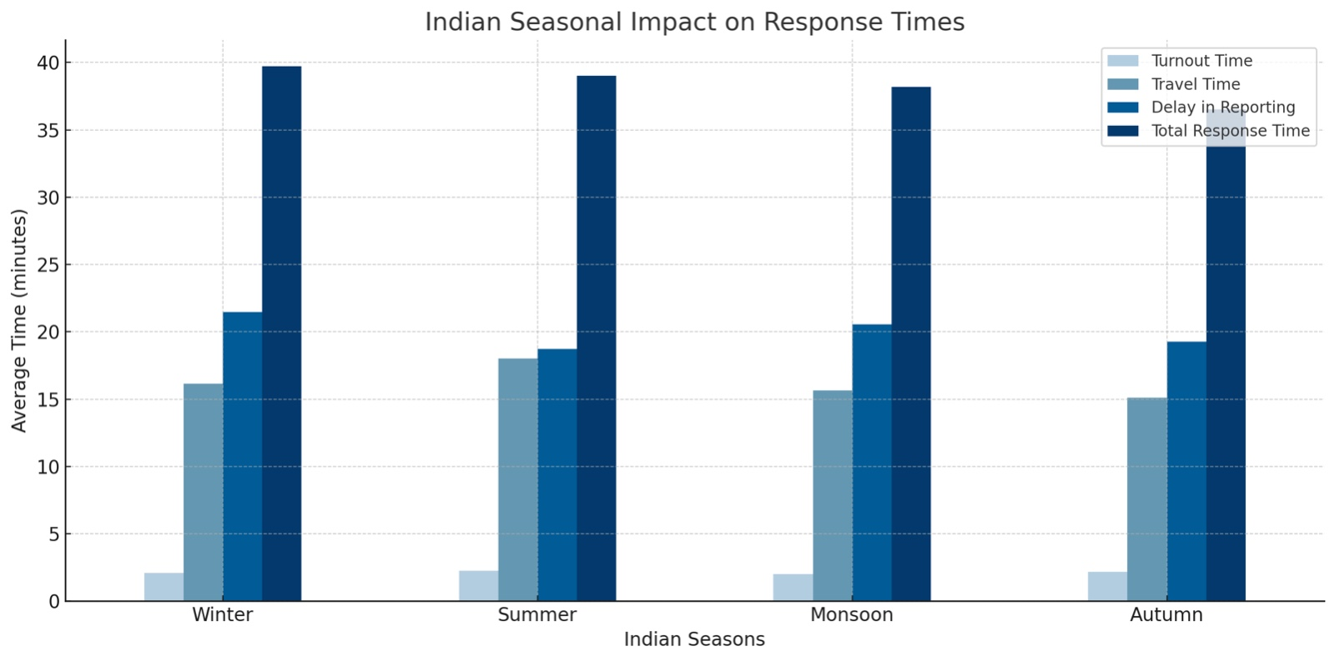

Image: Variation in different components of response time across seasons.

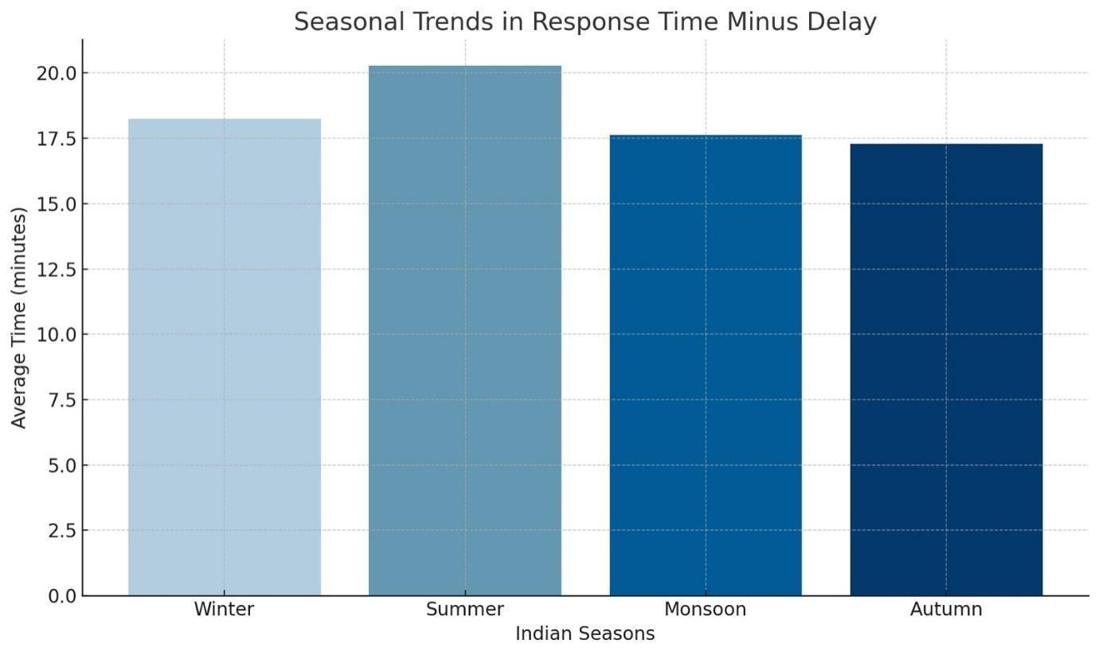

**Image:** Variation in response time during different seasons.

### 1. Winter (Moderate Response Time)

* **Foggy Conditions**: During winter, dense fog often reduces visibility on roads, slowing down fire trucks. This is especially common in the early mornings and evenings.
* **Traffic Challenges**: Lower traffic during winter may partly offset the delay caused by fog, resulting in moderate response times compared to other seasons.
* **Rural Heating Practices**: Increased use of firewood or kerosene for heating in rural areas might contribute to a higher frequency of fire incidents, requiring longer travel distances for fire services.

### 2. Summer (Highest Response Time)

* **Increased Fire Incidents**:
  + High temperatures and dry conditions make summer prone to fire hazards, particularly in rural areas where agriculture-related fires (e.g., stubble burning) are common.
  + Increased electrical load due to air conditioners and fans can lead to electrical fires, especially in urban centres with older infrastructure.
* **Heatwave Impact**:
  + Firefighting teams may experience exhaustion, impacting operational efficiency during extended fire incidents.
  + Heatwaves make firefighting more challenging, as equipment and personnel are stressed by high temperatures.

### 3. Monsoon (Moderate to Low Response Time)

* **Flooding and Waterlogging**:
  + Bihar is prone to severe monsoon flooding, especially in areas near the Kosi, Gandak, and Bagmati rivers. Flooding can make many areas inaccessible for fire trucks, contributing to delays.
  + However, natural dampness due to rain reduces the likelihood of widespread fires, which might slightly lower response times on average.
* **Infrastructure Challenges**:
  + Roads in rural and semi-urban areas often deteriorate during the monsoon, leading to slower travel for emergency vehicles.

### 4. Autumn (Lowest Response Time)

* **Reduced Natural Hazards**:
  + Post-monsoon, the weather is relatively calm, with no extreme heat or waterlogging, which facilitates quicker responses.
* **Improved Road Conditions**:
  + After the monsoon, some repairs to infrastructure might improve road accessibility.
* **Lower Fire Incidents**:
  + With moderate weather and reduced use of heating or cooling systems, the number of fire incidents might decrease, allowing firefighters to respond more efficiently.

### General Observations for Bihar

* **Seasonal Workload**:
  + Fire departments may face varying workloads across seasons, with higher fire frequencies in summer and lower in autumn.
* **Geographical Spread**:
  + Rural and remote areas with poor infrastructure continue to face longer response times, irrespective of the season.
* **Administrative Challenges**:
  + Limited resources and personnel in Bihar fire service exacerbate delays, especially during peak seasons like summer and monsoon.

**3. Bottleneck Identification**

**3.1. Dispatch Procedures**

**3.1.1 Fire Incident Reporting and Dispatch Analysis**

**Detailed Issue and Analysis Table**

|  |  |  |  |  |  |
| --- | --- | --- | --- | --- | --- |
| **Reporting Source** | **Issues Identified** | **Root Causes** | **Impact Severity** | **Improvement Strategies** | **Priority Level** |
| ERSS (112 Call) | - Procedural Delays in routing calls to fire personnel at ERSS HQ  - Unnecessary info collection in case of fire calls leading to delay in information relay - Lack of expertise from the perspective of fire incidents   - High call volume/Fake calls overwhelming operators. | - Lack of real-time GIS integration.  - Insufficient operating staff  - Manual Dispatch process (ERSS to Fire Station) | High | - Reduce the questionnaire in case of Fire emergency  - Integrate advanced GIS mapping tools for location tracking.  - Deploy automated triage systems using AI for call categorization and prioritization. | Critical |
| State HQ | - Delays in coordination with fire stations. (Manual Communication)  - High call volume during peak fire season overwhelming operators. - Understaffed State HQ  - Lack of Soft Skills | - Over-reliance on manual communication.  - Lack of Specific training Module for operators | High | - Implement centralized dispatch software. | Critical |
| District HQ | - Lack of clarity in inter-district resource allocation.  - Lack of interdepartmental coordination (Ex-Traffic, Municipality etc) | - No standardized resource-sharing protocols.  - SOP for internal departmental coordination not followed properly. | Medium | - Establish digital resource management systems.  -  Digitize SOPs and update them quarterly. | Medium |
| Fire Station | - Response delays during peak hours. | - Staffing inadequacies. | High | - Data-driven shift optimization. | High |
| Fire Service Personnel | - Poor navigation to incident locations.  - Inefficient cross-agency collaboration during emergencies. | - Outdated maps or lack of GPS integration.  - Lack of inter-agency communication protocols. | High | - Equip personnel with GPS-enabled mobile devices.  - Conduct joint training sessions and implement shared communication platforms. | Critical |

**3.2 Alert System:**

* **Manual System of Alert**: Traditional methods such as iron rods or mechanical bells are still used in most locations. While simple and cost-effective, they are often inefficient, as they rely on human intervention and are limited in range and effectiveness.
* **Electronic Bell**: The introduction of electronic bells has improved the alert system, but issues like low audibility in certain areas, especially in large buildings or noisy surroundings, reduce their reliability.
* **Lack of integration with modern communication systems**: Many alert systems are not integrated with digital communication tools such as mobile notifications, SMS, or wireless radios, which could ensure faster and broader dissemination of alerts.
* **Delayed response in remote areas**: In rural or remote regions, the absence of automated or real-time alert systems can lead to significant delays in mobilizing fire teams.
* **No redundancy for system failures**: Many existing alert systems lack backup mechanisms. A malfunction in the primary system, whether manual or electronic, can lead to critical delays in response time especially during natural hazards like earthquakes.
* **Limited coverage of alarm systems**: The reach of current alert mechanisms is often confined to a small radius, failing to notify teams stationed at distant or secondary locations.
* **Inefficient prioritization of alerts**: Without a centralized alert system, it is challenging to prioritize incidents based on severity, leading to potential misallocation of resources.
* **Inadequate training on new alert technologies**: In areas where modern alert systems have been installed, fire personnel may not be fully trained on their usage, resulting in underutilization of the technology.

**3.3. Personnel Mobilization Analysis**

|  |  |  |  |  |  |
| --- | --- | --- | --- | --- | --- |
| **Aspect** | **Issues Identified** | **Root Causes** | **Impact Severity** | **Improvement Strategies** | **Priority Level** |
| Team Assembly | - Delays in assembling teams. | - Personnel on 24 hr shifts  -Inefficient Alert channels during emergencies. | High | - Establish a centralized communication system and automated alerts. | Critical |
| On-Ground Coordination | - Inefficient allocation of personnel to locations. | - Lack of real-time situational awareness. | High | - Use GPS-enabled tracking for resource deployment. | Critical |
| Response Time | - Personnel taking longer to reach assembly points. | - Limited availability of transport during peak hours. | Medium | - Optimize transport logistics and maintain reserve vehicles. | High |
| Inter-Agency Collaboration | - Delays in coordinating with other emergency services. | - Absence of unified protocols. | High | - Implement inter-agency training and shared digital platforms. | Critical |

**3.4 Route Selection:**

* **Outdated map data**: Maps that are not regularly updated can result in navigational errors, such as directing vehicles to closed roads, newly constructed areas, or inaccurate locations. Use of paper maps by fire service/ Digitisation of routes is long due.
* **Inability to adapt to sudden traffic changes**: Navigation tools lacking dynamic rerouting capabilities may fail to address unexpected traffic congestion, roadblocks, or adverse weather conditions, leading to significant delays. This is majorly due to a lack of interdepartmental communication training. (The communication to traffic police is done via District Control room)
* **Narrow Routes With respect to large Fire tenders**: Routes that do not consider factors such as the size, weight, or clearance height of fire service vehicles can cause safety hazards or limit access to critical areas.
* **Over-dependence on fixed routing**: Relying strictly on predetermined routes without factoring in real-time updates or flexibility in navigation can reduce responsiveness and prolong travel times during emergencies. (Fixed routing to Hot spot Areas)
* **Limited integration with advanced GPS features**: Navigation systems that do not incorporate functionalities like live traffic updates, alternate route options, or predictive analytics may lead to inefficient and delayed route planning.

**4. Root Cause Analysis**

**Key Causes:**

1. **Outdated Infrastructure and Systems**
   * Limited use of real-time GIS mapping and GPS-enabled tools.
   * Reliance on manual or traditional alert systems, leading to delays.
   * Lack of dynamic route planning and outdated maps.
2. **Operational Inefficiencies**
   * Insufficient staffing levels, especially during peak hours or emergencies.
   * Procedural delays caused by manual communication and obsolete SOPs.
   * Delayed inter-agency coordination due to the absence of unified protocols.
3. **Resource Limitations**
   * Insufficient and outdated firefighting vehicles and equipment.
   * Inadequate maintenance of essential tools and vehicles.
   * Lack of advanced firefighting tools for complex scenarios.
4. **Infrastructure Constraints**
   * Narrow, poorly maintained roads and inadequate emergency lanes.
   * Encroachments and overcrowded urban areas obstruct vehicle movement.
   * Limited bridge capacity and inaccessible rural areas.
5. **Training and Technology Gaps**
   * Inefficient use of available technologies due to lack of training.
   * Absence of automated systems for escalation and resource prioritization.
6. **Environmental and Geographic Challenges**
   * Frequent flooding and poor drainage systems causing road blockages.
   * Remote and rural areas lacking proper connectivity.

**Root Cause Analysis Chart**

|  |  |  |  |
| --- | --- | --- | --- |
| Category | Key Causes | Impacts | Suggested Solutions |
| Infrastructure | Narrow roads, outdated maps, and encroachments. | Delayed response times and obstructed vehicle movement. | Regular road maintenance, emergency lanes, and dynamic GIS mapping systems. |
| Alert Systems | Manual alerts, no redundancy, and low audibility. | Inefficient notification leading to delayed team mobilization. | Automated digital alert systems integrated with SMS and mobile apps. |
| Resource Management | Shortage of vehicles, outdated equipment, and limited maintenance. | Reduced operational readiness and delayed fire responses. | Increase budget allocation for vehicles, tools, and maintenance. |
| Coordination | Inefficient inter-agency collaboration and lack of shared platforms. | Poor on-ground coordination and delayed decision-making. | Introduce unified protocols and real-time shared communication platforms. |
| Operational Procedures | Obsolete SOPs and inefficient team mobilization. | Unorganized response leading to inefficiency during emergencies. | Digitize and regularly update SOPs; optimize team shifts and assembly. |
| Environmental Challenges | Flooded or eroded roads, limited bridges, and inaccessible rural areas. | Significant delays in fire service response during emergencies. | Build resilient infrastructure, improve connectivity, and use alternate modes like drones for surveillance. |
| Technology Gaps | Lack of training in modern systems and absence of dynamic routing capabilities. | Underutilization of tools and inefficient navigation to incident sites. | Conduct regular training and equip teams with advanced GPS-enabled devices. |

# 

# 

# 

# 5.Geographic and Resource Analysis

**5.1 Coverage Analysis**

**1. Response Zones Analysis**

* Bihar currently has 107 fire stations across its 40 revenue districts (Source: Bihar Fire Services). However, these stations are unevenly distributed, with urban districts receiving more coverage, while rural areas remain underserved.
* High-demand districts such as Patna (11 fire stations), Muzaffarpur (6 fire stations), and Gaya (6 fire stations) have significantly better resources than rural districts like Sheohar (1 station) and Arwal (1 station).

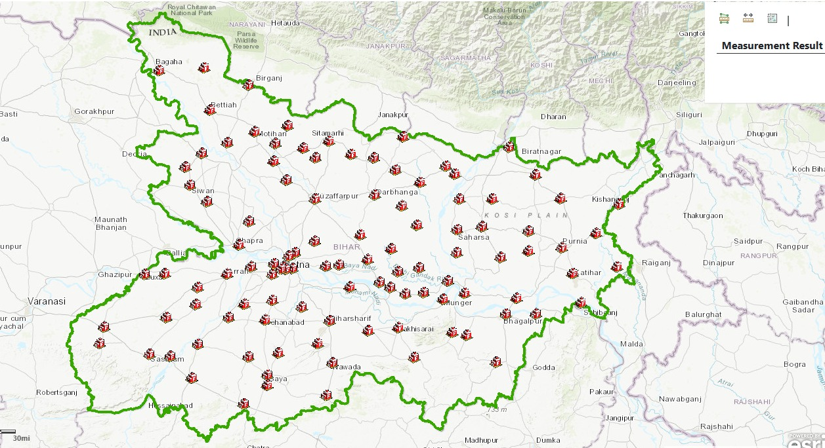

**Image**: Current Fire Stations in Bihar

### 5.2 High-Risk Areas Analysis

* Urban Areas: Cities like Patna, Bhagalpur, and Muzaffarpur report frequent residential and market fires due to high population density, congested spaces, and illegal electrical connections.
* Industrial Zones: Locations such as Hajipur, Barauni (Begusarai), and Muzaffarpur pose heightened fire risks due to hazardous materials and inadequate fire safety mechanisms.
* Rural Areas: Districts like Nalanda, Gaya, and Samastipur see increased fire incidents during harvest seasons, contributing to nearly 20% of total rural fire incidents annually.

**Key Findings**

* Patna’s Old City: Risky zones include narrow lanes in areas like Kadamkuan and Patna City. Market fires in Patna’s Bakarganj market were responsible for ₹20 crore in damages in 2022.
* Muzaffarpur: High risks due to dense population and industrial factories, with over 400 fire incidents reported annually.

**Recommendations**

* Conduct Detailed fire safety inspections for markets, factories, and slum areas.
* Install automated fire detection systems in high-risk zones.



**Image: High risk districts across the state.**

**5.3 Population Density Analysis**

* Bihar is India’s third-most populous state, with 104 million residents (Census 2011).
* Districts with highest population densities include Patna (1,823 people/sq. km), Nalanda (1,218 people/sq. km), and Vaishali (1,171 people/sq. km), leading to heightened fire risks.
* Comparatively, districts like Jamui (368 people/sq. km) and West Champaran (746 people/sq. km) have lower densities but also lack sufficient firefighting services.
* here appears to be direct correlation in population density and fire incidents

**Recommendations**

* Firefighting resources should be allocated proportionally based on population density.
* Implement Fire prevention awareness programs in densely populated areas.

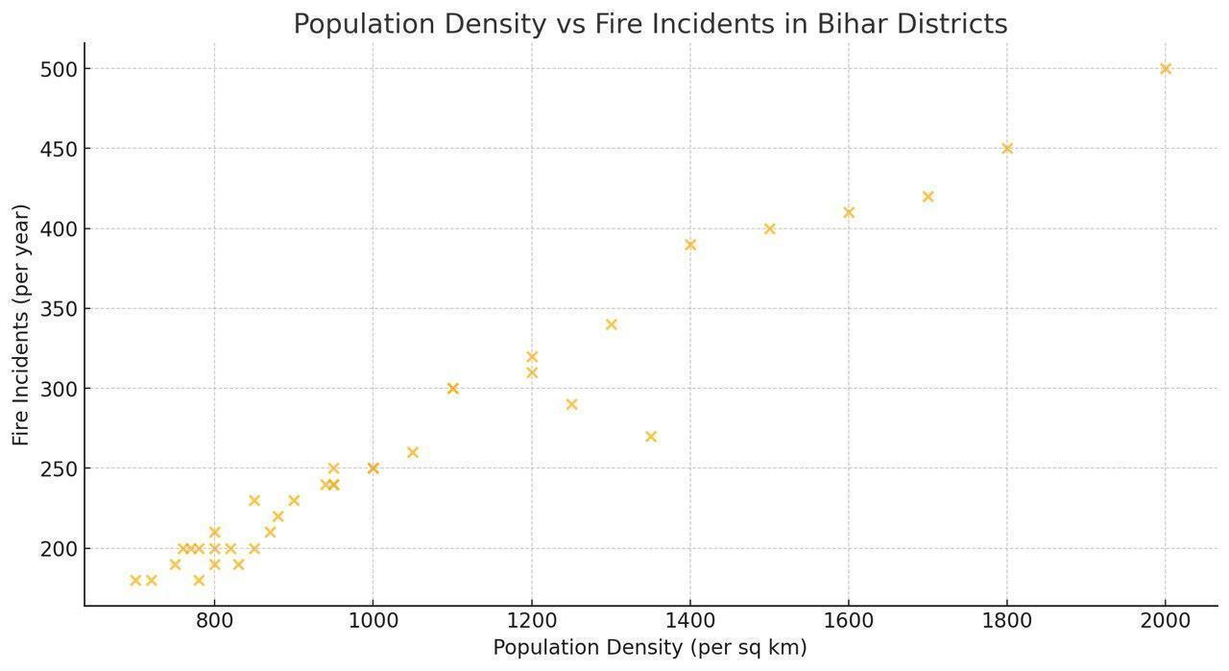

**5.4 Traffic Patterns Analysis**

* Urban Bottlenecks: Cities like Patna (Bailey Road, Ashok Rajpath, and Gandhi Maidan) experience delays up to 20 minutes(Source: personnel Interviews) due to congestion.
* Smaller Towns: Locations such as Muzaffarpur and Bhagalpur face similar issues, while rural areas struggle with unpaved roads and poor connectivity.

**Key Findings**

* Traffic congestion is the most significant barrier to timely firefighting response in urban areas.
* Peak Vs. Off-Peak Delays: Average response time in Patna during peak traffic hours is 20–25 minutes compared to 15–20 minutes during off-peak hours.(Source: personnel Interviews)

**Recommendations**

* Establish dedicated fire lanes or bypass routes in high-congestion areas.
* Use Real-time traffic monitoring to prioritize fire engine movement.

### 5.5 Road Network Analysis

* Bihar has a road density of 174 km per 100 sq. km (higher than the national average of 139 km), but rural areas face connectivity issues.
* Urban areas like Patna have strong road networks, but congested lanes slow down emergency response. In contrast, rural districts like Araria and Banka face challenges due to unpaved roads.

**Key Findings**

* Narrow lanes in urban slums and bazaars (e.g., Patna City) prevent easy fire tender movement.
* Fire Response is severely delayed in flood-prone districts like Darbhanga, where road access is compromised during monsoons.

**Recommendation:**

* Improve rural road infrastructure with all-weather roads and broader lanes in urban slums and bazaar areas.

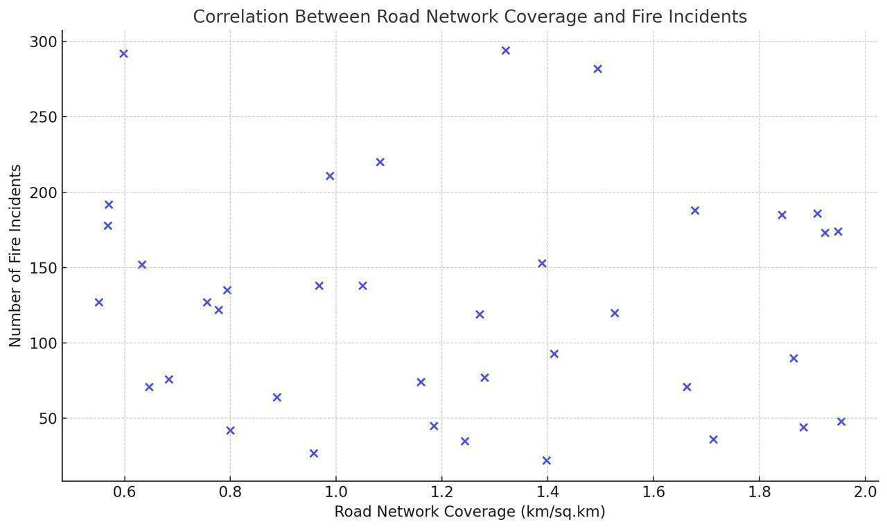

### 5.6 Construction Zones Analysis

* Ongoing construction in cities like Patna (Metro Project) and Bhagalpur leads to blocked roads and increased fire risks due to flammable materials
* Smaller towns experiencing rapid urbanization often neglect fire safety regulations.

**Key Findings**

* Patna Metro Construction: Delays fire tenders in areas like Rajendra Nagar and Gandhi Maidan.
* Industrial hubs like Hajipur and Barauni face higher risks due to inadequate fire safety compliance. Recommendations
* Strict enforcement of fire safety norms at construction sites.
* Allocate firefighting resources near large-scale construction zones.

**5.7 Natural Barriers Analysis**

* Rivers such as the Ganges and Gandak hinder access in Bhagalpur, Samastipur, and Darbhanga.
* Forested areas in Jamui and West Champaran pose additional accessibility challenges.

**Key Findings**

* Monsoon floods in Bihar (affecting over 15 districts annually) significantly delay firefighting efforts in affected areas.

**Recommendations**

* Equip fire services with boats and off-road vehicles to address natural barrier challenges.

### 5.8 Future Development Areas Analysis

* Patna’s projected urban growth (expected 3.8 million residents by 2030) and industrial expansion in Hajipur and Barauni require enhanced firefighting resources.
* Future development prospects shall be viewed from the lens of fire safety and measures for fire prevention and fire fighting shall be made part of developmental projects.

# 

# 6. Resource Distribution:

## 6.1 Fire Station location

Bihar currently operates 107 fire stations across its 40 revenue districts.

|  |  |  |  |
| --- | --- | --- | --- |
| **Analysis: Fire station** | | | |
| **District** | **Area(sq km)** | **SFAC (50 sq km)** | **Current** |
| Jamui | 3098 | 62 | **1** |
| Gaya | 4976 | 99 | **5** |
| Buxar | 1703 | 34 | **2** |
| Aurangabad | 3305 | 66 | **2** |
| Nawada | 2494 | 49 | **2** |

* **Key Challenges:**
  + Inadequate infrastructure: The number of fire stations is insufficient to meet SFAC guidelines of one station per 10 sq. km in urban areas and one per 50 sq. km in rural areas.
  + The above table highlights the required number of fire stations in any district (according to its area) recommended by SFAC (standing fire advisory committee) and current number of fire stations located in those districts. The chosen districts are those where travel time is maximum.
  + Delayed responses: Traffic congestion and insufficient staffing contribute to response delays, particularly during peak hours and fire seasons (Summer).
  + Coordination issues: A lack of clarity and procedural delays in inter-district resource allocation and coordination hampers timely responses to calls received at the headquarters level.
  + High operational burden: Personnel face overwhelming call volumes during peak fire seasons.

## 6.2 Vehicle Positioning

Bihar’s fire service operates with **798 vehicles**, including,

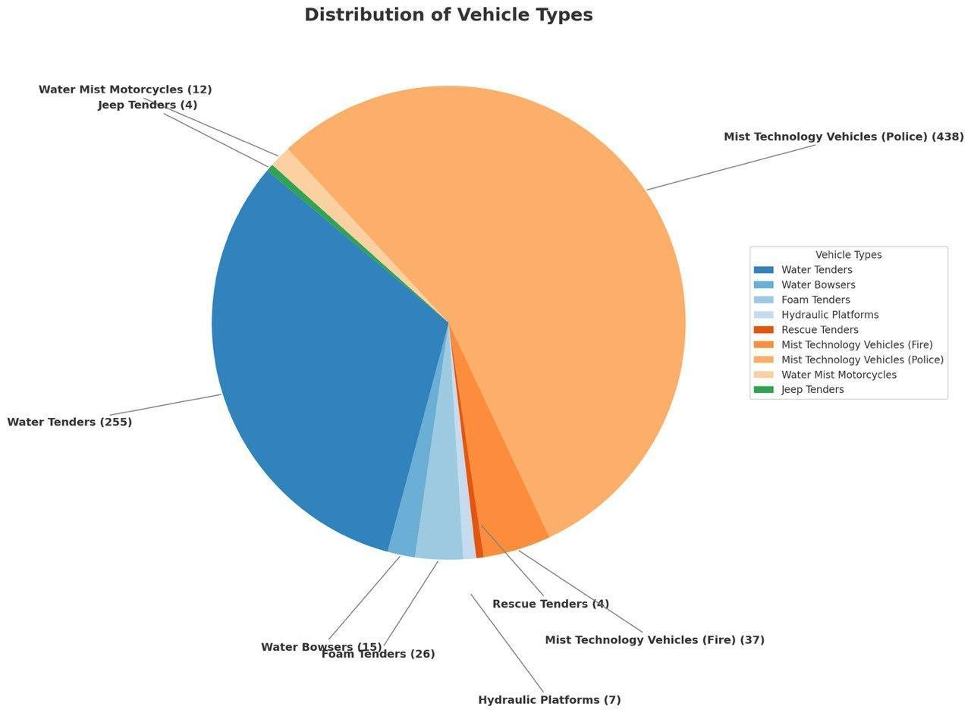

* **Key Challenges**:
  + **Insufficient fleet size relative to population**: As per SFAC guidelines, one fire tender is required per 50,000 people up to a population of 3 lakhs. Current capacity falls short, especially during peak fire seasons.
  + **Geographical imbalance :** Specialized vehicles, such as hydraulic platforms (6 in Patna, 1 in Gaya) and water mist motorcycles (12 in Patna), are concentrated in a few districts.
  + **Aging fleet:** Many vehicles are outdated, lack advanced GPS systems, and are prone to frequent breakdowns, exceeding the SFAC-prescribed operational life of 10 years or 5,000 hours of stationary operation.
  + **Traffic-related delays**: The absence of dedicated emergency lanes increases response times.

## 6.3 Personnel Deployment

**Current Situation:**

The Bihar Fire Services currently have the following personnel deployed across various roles:

|  |  |
| --- | --- |
| **Role** | **Current Strength** |
| **Assistant District Fire Officers (ADFO)** | 36 |
| **Station Fire Safety Officers (SDFSO)** | 94 |
| **Station Officers** | 97 |
| **Leading Firemen** | 183 |
| **Leading Drivers** | 2 |
| **Firemen** | 2,948 |
| **Firemen Drivers** | 868 |

### Key Challenges:

#### **1. Delayed Mobilization**

* Inefficiencies in assembling teams and coordinating with relevant departments such as Traffic, Electricity, Municipality, and Patna Metro.
* Slow response time due to procedural delays and lack of real-time tracking mechanisms.

#### **2. Manpower Shortages**

* Significant vacancies affecting operational effectiveness across the state:
  + **49 ADFOs**, **42 SDFSOs**, **117 Leading Firemen**, **269 Leading Drivers** remain unfilled.
* Limited personnel available for peak fire seasons and emergency responses.

#### **3. Training Gaps**

* Insufficient training in **modern firefighting technologies** and **emergency management techniques**.
* Lack of specialized skill development programs for handling advanced fire fighting equipment.

### 

### 6.4 Equipment Allocation

### Key Challenges:

#### **1. Outdated Tools & Technology**

* Many firefighting tools are obsolete, impacting response efficiency.
* **Older water tenders (especially outside Patna)** require frequent pressure maintenance, leading to delays in operations.

#### **2. Gaps in Equipment Maintenance Protocols**

* Firefighting equipment is only checked **weekly (every Saturday)**, which may not be sufficient.
* More frequent maintenance cycles should be introduced to ensure readiness at all times.

**Recommendations:**

* Upgrade **fire tenders and essential firefighting equipment** across districts.
* Implement **automated maintenance tracking systems** for regular servicing of equipment.
* Introduce **real-time equipment monitoring** to detect faults and failures proactively.

**6.5 Mutual Aid Arrangements**

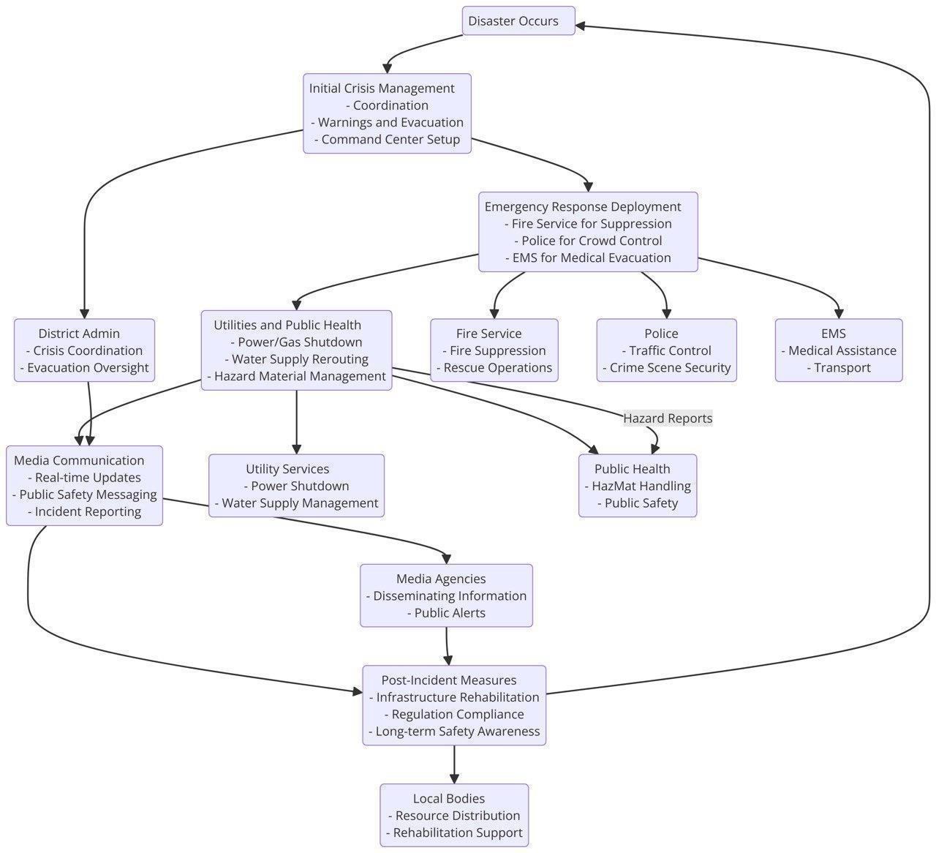

**Constraints and Solutions**

### Key Constraints

#### **1. Communication Barriers**

* Lack of a clear line of communication and instructions.
* Inconsistent messaging due to the absence of a central communication framework.
* Risk of messages being distorted or lost between departments.

#### **2. Conflicting Priorities**

* Resource allocation conflicts arise due to competition for limited resources such as manpower, time, and funding.
* Lack of clear prioritization leads to inefficiencies and operational delays.

#### **3. Siloed Thinking**

* Lack of cross-department knowledge and collaboration.
* Competition for credit instead of fostering teamwork.
* Absence of a shared vision and a common discussion platform for accountability.

#### **4. Process and System Inefficiencies**

* Ambiguity in roles and responsibilities results in slow decision-making.
* Lack of standardized processes burdens employees with unnecessary tasks.
* Over-reliance on manual operations instead of streamlined digital processes.

### Recommended Solutions

#### **1. Promote Open and Transparent Communication**

* Establish a **centralized communication system** for seamless information sharing.
* Implement **standardized protocols** to reduce message distortion and enhance clarity.

#### **2. Foster a Culture of Collaboration**

* Encourage **cross-departmental teamwork** through joint training and meetings.
* Develop an **integrated communication platform** for shared discussions and updates.

#### **3. Implement Clear Processes and Tools**

* Define **standard operating procedures (SOPs)** to streamline decision-making.
* Automate routine processes to **reduce manual inefficiencies**.

#### **4. Create Accountability and Reward Systems**

* Establish **clear accountability structures** for roles and responsibilities.
* Introduce **performance-based incentives** to encourage efficiency and teamwork.

### 

### 

### 

### 

### 

### 

### 

### 

### 

### 

### SWOT Analysis: Bihar Fire Service Response Time Optimization

#### **Strengths**

* Well-established network of **107 fire stations** across 40 districts.
* Presence of **trained fire personnel** with operational experience.
* Integration with **Emergency Response Support System (ERSS 112)**.
* Increasing adoption of **modern firefighting vehicles and equipment**.

#### **Weaknesses**

* **Manual call handling** processes leading to delays in dispatch.
* **Inconsistent interdepartmental coordination**, impacting response time.
* **Limited adoption of real-time GPS tracking** for fire tenders.
* **Shortage of trained personnel** in critical districts.

#### **Opportunities**

* Implementation of **AI-based dispatch optimization** to enhance efficiency.
* Use of **drone-assisted navigation** for real-time route planning.
* Deployment of **smart traffic management systems** for faster fire tender movement.
* Expansion of **fire stations in high-risk zones** to reduce travel time.

#### **Threats**

* **Urban congestion and poor road conditions** delaying response time.
* **Limited budget allocation** for advanced firefighting technologies.
* **Extreme weather conditions (floods, heatwaves)** impacting mobility.
* **Increasing fire incidents in industrial and residential areas** adding pressure on resources.

### 

### PESTEL Analysis: Bihar Fire Service Response Time Optimization

#### 

#### **Political Factors**

* Government policies on **fire safety regulations** and emergency response funding.
* Bureaucratic delays in **fire service modernization initiatives**.
* **Inter-agency coordination** between fire services, law enforcement, and municipal authorities.

#### **Economic Factors**

* **Budget constraints** affecting investment in new fire stations, equipment, and personnel.
* Economic disparities leading to **unequal distribution of resources** across urban and rural districts.
* Insurance policies and their impact on **fire safety investments in businesses and industries**.

#### **Social Factors**

* Public awareness and **fire safety education programs** to reduce fire incidents.
* Population density affecting **response times in congested urban areas**.
* Community involvement in **volunteer fire services** and emergency preparedness.

#### **Technological Factors**

* Adoption of **real-time GPS tracking and AI-based dispatch optimization**.
* Use of **drone technology for fire assessment and route navigation**.
* Development of **smart fire detection and automated alert systems**.

#### **Environmental Factors**

* Impact of **climate change on fire frequency**, especially in summer months.
* Monsoons causing **flooded roads that delay fire truck movement**.
* Need for eco-friendly firefighting solutions to **reduce environmental impact**.

#### **Legal Factors**

* Compliance with **national and state-level fire safety laws**.
* Regulations on **firefighter training, occupational safety, and equipment standards**.
* Legal accountability in **fire-related accidents and emergency response failures**.

**7. Optimization Strategy**

**A. Improvement Plan**

Case Study: ERSS Bihar Response time optimization**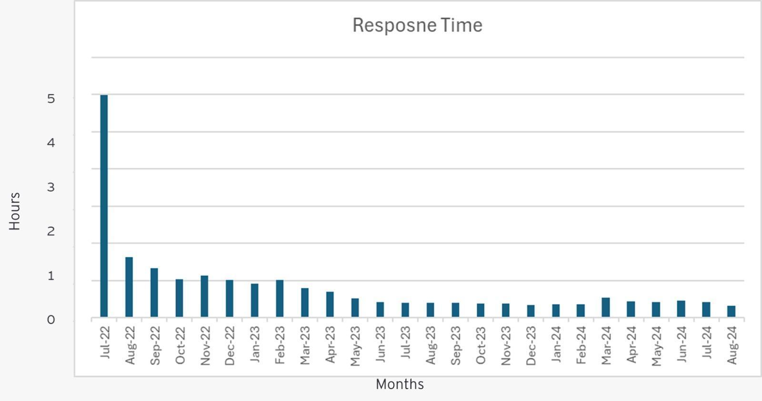Image**: ERSS Bihar Response time

Bihar's Emergency Response Support System (ERSS) has significantly reduced response time From 5 hours in July 2022 to 15 minutes in August 2024. However, a temporary increase post-March 2024 occurred due to an increase in response vehicles without a corresponding rise in personnel, leading to longer shifts and fatigue. A balance between fleet expansion and workforce allocation is crucial to maintaining efficiency.

The strategy implemented by **ERSS Bihar** to achieve this milestone has been included in the **Optimization Strategy and Implementation Framework**.

**7.1 Call Handling Optimization**

1. **Standardized Emergency Scripts:** Develop and enforce uniform response protocols to swiftly extract critical information, including the fire’s location, nature, and the presence of injuries.
2. **Priority Classification System:** Implement predefined priority codes (e.g., structural fires, vehicle fires, hazardous material incidents) to assess urgency and allocate resources efficiently.
3. **Digital Fire Reporting:** Promote mobile app-based fire incident reporting integrated with GPS and caller identification to accelerate response times.
   1. *Case Study:* Finland has successfully implemented a mobile app that enables residents to report fires in real time, improving response efficiency.
4. **IoT-Based Fire Alerts:** Deploy IoT sensors in high-risk locations such as hospitals, industrial zones, and commercial buildings to generate automated fire alerts and enable rapid response.
5. **Dynamic Resource Allocation:** Utilize real-time analytics in dispatch systems to allocate fire units based on live traffic, road conditions, and resource availability.

**7.2 Turnout Time Optimization**

**Strategic Recommendations:**

1. **Integrated Alert Systems:** Implement smart dispatch systems that provide multi-channel notifications (e.g., pagers, mobile apps, digital radios) to deliver incident details instantly.
2. **Pre-Alert Mechanisms:** Introduce pre-alert systems to notify personnel in advance, allowing them to prepare while dispatch details are being finalized.
   * *Case Study:* In Germany, automated systems instantly notify firefighters, enabling immediate preparation and reducing response delays.
3. **Optimized Shift Patterns:** Adopt structured eight-hour shifts to ensure personnel remain physically and mentally prepared, especially during nighttime operations.
4. **Vehicle Readiness Protocols:** Establish stringent pre-shift vehicle inspection standards and integrate automated pre-start checks to ensure fire trucks are always deployment-ready.

**7.3 Route Optimization**

1. **Real-Time Traffic Data Integration:** Collaborate with traffic authorities (e.g., Delhi Traffic Police, Mumbai Traffic Control) to access live traffic updates and avoid congestion.
   1. *Case Study:* Singapore integrates real-time traffic data into fire truck GPS systems, enabling route optimization to avoid jams and expedite arrival.
2. **Drone-Assisted Navigation:** Employ drones for traffic surveillance and site assessment, allowing fire vehicles to navigate more efficiently.
   1. *Example:* Kerala’s fire department has successfully deployed drones for enhanced situational awareness.
3. **Strategic Prepositioning of Fire Units:** Dynamically position fire vehicles in high-risk zones based on historical data, community mapping, and live traffic conditions.
   1. *Example:* Fire stations in Kolkata and Delhi are strategically located near industrial areas, crowded markets, and residential complexes for quicker response times.
4. **Training on Route Optimization:** Conduct specialized training for personnel on navigation tools and real-time route optimization systems.
5. **Dedicated Emergency Lanes:** Develop and enforce marked emergency lanes in urban areas, as successfully implemented in Hyderabad and Chennai.
6. **Smart Traffic Management:** Install adaptive traffic signals that prioritize fire vehicles during emergencies.
   1. *Case Study:* Cities like Seoul and Dubai have integrated emergency services with traffic control systems, turning lights green when fire trucks approach.

**7.4 Resource Deployment**

1. **Volunteer Fire Brigades:** Establish and support volunteer firefighter units in rural areas to enhance local response capabilities.
   * *Example:* New Zealand relies on a strong network of volunteer firefighters to reduce response times in remote areas.
2. **Shift Reforms:** Transition from traditional 24-hour shifts to 12-hour, and eventually 8-hour shifts to improve efficiency and readiness.
3. **Strategic Station Locations:** Position fire stations in high-risk zones such as industrial hubs, commercial centers, and densely populated areas.
   * *Example:* Germany and Australia conduct regular studies to optimize fire station placement based on response time analytics.
4. **Hotspot Identification:** Update high-risk area mapping annually using previous year data to ensure proactive planning before peak fire seasons.
5. **Knowledge Documentation:** Establish a structured knowledge transfer system for fire personnel to document and share operational insights, including route selection, hydrant locations, and geographical barriers.
6. **Encouraging Bhraman (Field Exploration):** Implement a structured incentive program for personnel to explore their jurisdictions, enhancing situational awareness.
7. **Integrated Command and Control Center (ICCC):** Develop a centralized emergency response system similar to Japan’s National Fire and Disaster Management Agency, enabling coordinated deployment and resource management.

**7.5. Training Enhancement**

1. **Advanced Simulation Training:** Utilize VR and AR technologies for scenario-based training, simulating various fire conditions and emergency scenarios.
   * *Case Study:* Finland heavily invests in VR simulation tools, improving firefighter preparedness and response effectiveness.
2. **Stress Management Drills:** Conduct high-pressure, time-sensitive drills to enhance decision-making efficiency under real emergency conditions.
3. **Inter-Agency Training Programs:** Organize joint exercises with paramedics, police, and emergency medical teams to improve coordination and communication.
4. **Technology Training:** Equip personnel with skills to operate advanced communication, GPS, and live data tracking systems to optimize response strategies.

**7.6. Technology Integration**

1. **Drone Deployment:** Equip drones with thermal imaging cameras to assess fire intensity, spread, and structural damage in real time.
2. **Predictive Analytics for Fire Prevention:** Implement AI-driven models to analyze historical and real-time data for predicting fire patterns and optimizing resource allocation.
3. **AI-Based Dispatch Optimization:** Leverage artificial intelligence for dynamic allocation of personnel, vehicles, and equipment based on emergency specifics, minimizing manual decision-making delays.

**8. Implementation Framework**

### 8.1 Short-term Improvements (0-3 months)

1. **Enhanced Data Collection & Reporting:**
   * Standardize fire incident data collection at state, district, and station levels to minimize reporting errors.
   * Implement Google Forms or other digital tools for faster, more accurate data entry.
   * Maintain a centralized digital fire incident reporting system.
2. **Operational Enhancements:**
   * Develop and enforce standardized scripts for control rooms to quickly extract critical information (location, nature of fire, injuries, etc.).
   * Introduce predefined priority codes (e.g., structural fires, vehicle fires) to streamline emergency response and resource allocation.
   * Expedite the establishment and operationalization of the State Fire Control Room.
   * Accelerate the deployment and configuration of tablets in fire vehicles for real-time communication and navigation.
3. **Logistical & Tactical Improvements:**
   * Establish rigorous pre-shift vehicle inspection standards to ensure immediate readiness.
   * Integrate pre-start systems for fire vehicles to enhance response efficiency.
   * Collaborate with traffic authorities to access real-time traffic updates and avoid congestion. (Eg. Deploying fire service personnel at Police Information Room)
4. **Workforce Well-being & Efficiency:**
   * Encourage and incentivize weekly rest days (Bhraman) for firefighters to leverage their local knowledge in route selection, hotspot mapping, hydrant locations, and geographical barriers.

### 8.2 Medium-term Solutions (3-12 months)

1. **Personnel & Shift Management:**
   * Implement structured shift management to minimize firefighter fatigue, especially during high-risk summer months.
   * Reallocate resources based on geographical fire incident trends, ensuring regions with higher incident rates (e.g., North-West Bihar) receive adequate personnel and equipment.
2. **Technology & Communication Upgrades:**
   * Upgrade communication infrastructure for seamless coordination.
   * Develop an app-based fire incident reporting system integrated with GPS and caller identification for faster response.
   * Implement smart dispatch systems using multi-channel notifications (e.g., mobile apps, pagers, digital radios) to disseminate real-time updates to responders.
   * Provide targeted training for route optimization technologies to improve response times.
3. **Community Engagement & Support:**
   * Establish and support volunteer fire units in rural areas to enhance local emergency response capabilities.

### 8.3 Long-term Strategies (1-3 years)

1. **Infrastructure & Equipment Investments:**
   * Procure additional water tenders and rescue vehicles to expand operational capacity.
   * Implement an online fire incident reporting and monitoring system at station, district, and state levels to improve oversight and reduce response time delays.
   * Expand the number of fire stations to improve geographic coverage.
   * Upgrade fire station infrastructure, including better barracks and facilities for personnel.
2. **Advanced Fire Response Technologies:**
   * Deploy IoT-based fire detection sensors in high-risk areas (e.g., hospitals) to generate automated alerts.
   * Implement pre-alert mechanisms to allow fire personnel to prepare for deployment while dispatch details are being finalized.
   * Utilize drones for traffic surveillance and on-site assessment to optimize fire vehicle route planning.
   * Install adaptive traffic signals in major cities (e.g., Pune, Ahmedabad) to prioritize fire vehicles during emergencies.
   * Leverage AI-driven tools to analyze historical and real-time fire data for predictive response planning.
   * Establish an MoU with the Emergency Response Support System (ERSS) to enable Quick Response Units (QRUs) to handle initial firefighting efforts, following the model implemented in Odisha.

### 8.4 Resource Requirements

1. **Physical Infrastructure:**
   * Increase the number of fire stations to match growing urban and rural demands.
2. **Technological Resources:**
   * Develop and deploy advanced fire service management software, including dashboards providing views at different levels (station, district, state).
   * Digitize response processes for improved efficiency and transparency.
3. **Public Awareness Initiatives:**
   * Establish a dedicated team to conduct awareness campaigns aimed at reducing delays in fire incident reporting.

### 8.5 Training Needs

1. **Inter-Departmental Coordination:**
   * Conduct joint training programs with other emergency response agencies (e.g., police, paramedics) to enhance collaboration and minimize communication delays.
2. **Skill Development:**
   * Provide soft skills training for control room personnel to improve communication and response efficiency.
   * Specialised training for personnel involved in public awareness campaigns to effectively educate communities on fire safety and prevention.
3. **Simulation & Real-World Drills:**
   * Utilize VR and AR technologies to create immersive, scenario-based training modules simulating diverse fire conditions.
   * Conduct high-pressure drills with strict time constraints to cultivate calm and efficiency during emergencies.
   * Organize large-scale, multi-agency drills to test coordination and response effectiveness.

### 8.6 Budget Implications

1. **Dedicated Budget for Digitization:**
   * Allocate specific funds for the implementation of digital tools, reporting systems, and communication technology.
2. **Infrastructure Development:**
   * Secure long-term funding for fire station expansion, procurement of equipment, and workforce enhancement.
3. **Training & Public Awareness Initiatives:**
   * Ensure dedicated resources for training programs, awareness campaigns, and inter-agency coordination efforts.

**CONCLUSION**

The **Bihar Fire Service** plays a pivotal role in safeguarding lives and property across the state, yet its operational framework faces significant challenges that hinder efficiency. The findings of this report highlight critical areas requiring urgent intervention, such as **delayed response times, outdated infrastructure, resource shortages, and a lack of technological integration.** Despite these challenges, the dedication of fire personnel and the existing emergency response framework provide a strong foundation for improvement.

Through **comprehensive data analysis** covering over **7,000 fire incidents** across **40 districts**, this report has identified systemic bottlenecks, including **manual dispatch processes, inefficient coordination between agencies, infrastructure deficits, and inconsistent training.** High-risk districts like **Patna, Gopalganj, and West Champaran** require strategic investments in **fire stations, equipment modernization, and workforce expansion.** Urban centres suffer from **traffic congestion**, while rural districts face **geographical constraints** that prolong response times.

The **optimization strategy outlined in this report** provides a structured roadmap to **modernize the Bihar Fire Service** through short-term, medium-term, and long-term interventions. **Immediate solutions** include **digitizing incident reporting,** **training personnel in modern navigation systems**, and **enhancing inter-agency communication.** **Medium-term measures** focus on **expanding fire stations, introducing real-time GPS tracking**, and **deploying smart dispatch systems.** **Long-term reforms** involve **AI-based fire prediction, drone-assisted route optimization, and IoT-enabled fire detection systems.**

If the **recommendations are systematically implemented**, the Bihar Fire Service can significantly **reduce response times, enhance operational efficiency, and improve fire safety outcomes** across the state. However, success will require **consistent funding, political will, cross-agency collaboration, and a commitment to technology-driven reforms.**Addressing these issues proactively will **not only save lives but also enhance public confidence** in Bihar’s emergency response system.

End of Report